To solve this "Unable to Change Enhanced Power Management settings", please try following steps in your windows system.

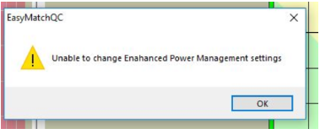

1) Open the Windows Registry editor (regedit.exe). This can be done from the “Run” command by pressing Windows+R and entering “regedit” (without the quotes) as the command.
2) Once the editor is open, expand the following key:
HKEY_LOCAL_MACHINE\SYSTEM\CurrentControlSet\Enum\USB
3) Look for the subkeys that begin with “VID_1D89”
4) For each subkey, do the following:
a. Expand the tree and select the subkey “Device Parameters”
b. Double-click on the value “EnhancedPowerManagementEnabled”
c. Set the “Value data” field to 0, click on OK
5) Close the editor.

